MARRIAGE ENRICHMENT EVENING

Come away with your spouse from your busy life to enjoy a practical talk about the importance of your vocation to married life and its significance for your eternal life.

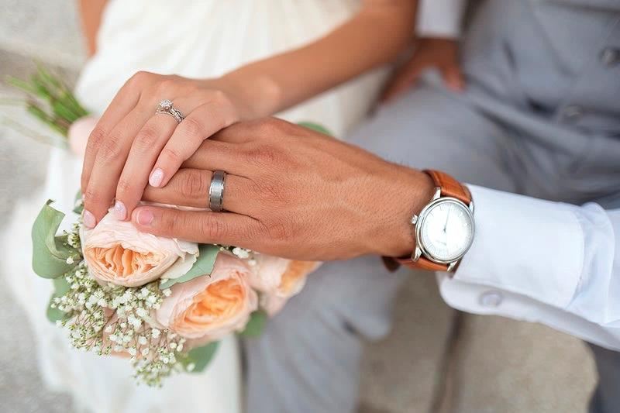
As Jesus transformed water into wine at the wedding feast of Cana, He has a plan for your marriage to help you prepare for our Eternal Wedding Banquet.

Date: | Schedule Includes:  Renewal of Marriage Vows  Divine Liturgy  Dinner  Music  Talk
LOCATION:  Church | COST: $ / couple  For registration, e-mail: Contact@gmail.com  Include your name, your spouse’s name and years of marriage.

